Curtin University – Department of Computing
Assignment Cover Sheet / Declaration of Originality
Complete this form if/as directed by your unit coordinator, lecturer or the assignment specification.
Last name: | Bello | Student ID: | 22504704
Other Name(s): | Alan Michael
Unit Name: | Data Structures and Algorithms | Unit ID: | COMP5008
Lecture/Unit coordinator: |  | Tutor: | Ying Li
Date of submission: | 28th May 2026 | Which assignment?
I declare that:
- The above information is complete and accurate.
- The work I am submitting is entirely my own, except where clearly indicated otherwise and correctly referenced.
- I have taken (and will continue to take) all reasonable steps to ensure my work is not accessible to any other students who may gain unfair advantage from it.
- I have not previously submitted this work for any other unit, whether at Curtin University or elsewhere, or for prior attempts at this unit, except where clearly indicated otherwise.
I understand that:
- Plagiarism and collusion are dishonest, and unfair to all other students.
- Detection of plagiarism and collusion may be done manually or by using tools (such as Turnitin).
- If I plagiarize or collude, I risk failing the unit with a grade of ANN (“Result Annulled due to Academic Misconduct”), which will remain permanently on my academic record. I also risk termination from my course and other penalties.
- Even with correct referencing, my submission will only be marked according to what I have done myself, specifically for this assessment. I cannot re-use the work of others, or my own previously submitted work, in order to fulfil the assessment requirements.
- It is my responsibility to ensure that my submission is complete, correct and not corrupted.
Signature:  Date of signature: 28th May 2026
(By submitting this form, you indicate that you agree with all the above text.)
ZipRide Dispatch System
Data Structures and Algorithms for Efficient Ride-Hailing
- Introduction
ZipRide is a rapidly expanding ride-hailing service operating across a densely populated metropolitan area. The ZipRide Dispatch System is responsible for continuously pairing riders with the nearest available driver, maintain up-to-date passenger and driver data, priorities and dispatch the highest-priority pickup requests, and produce dispatch performance reports. All of this must be achieved with minimal latency.
For this project, we designed and implemented a backend ZipRide Dispatch System using fundamental data structures and algorithms components such as Graph, Hash Table, Heap, and Sorting. These four modules form an integrated pipeline supporting real-time operational decision-making as well as post-dispatch analysis.
Module | Data Structure | Role in ZipRide
1 | Weighted Graph (Adj. List) | City road network; BFS, DFS, Dijkstra shortest paths
2 | Hash Table (Open Addr.) | O(1) lookup of passenger tier and driver location/status
3 | Max-Heap | Priority queue: nearest-driver + highest-tier dispatched first
4 | Merge Sort & Quick Sort | End-of-day sort of pickup records by EstimatedPickupTime
- Module 1 calculates driving times
- Module 2 gives instant access to passenger and driver information
- Module 3 computes priority and schedules dispatch accordingly
- Module 4 sorts completed rides for reporting and analysis
This design helps ZipRide deliver fast, reliable matches and keeps the system organized.
- Learning Objectives
The goal of this assignment was to build a real-world dispatch system using four core data structures. Through this project we:
- Built a city road network as a graph and used BFS, DFS and Dijkstra to find routes and detect cycles
- Created a hash table from scratch to store and quickly retrieve passenger and driver records
- Built a priority-based scheduler using a max-heap that assigns the nearest driver to the highest-tier passenger first
- Implemented and compared merge sort and quick sort by testing them on datasets of different sizes and conditions
- Connected all four modules into one working system where each module feeds data into the next
- Module 1: Graph-Based Route Planning
  - Problem Description
The ZipRide city road network was modelled as a weighted, undirected graph. Nodes represent city locations and Edges represent roads between them. Each edge weight is the driving time in minutes between two locations.
- Nodes represent locations: CBD, Airport, University, Suburb North, Suburb South, Shopping Mall, Hospital, Industrial Park, Tech Park.
- Edges represent roads between locations.
- Weights are driving time in minutes.
The graph structure enables the system to perform route analysis and dispatch optimization using graph traversal and shortest path algorithms
  - Tasks
    - Graph Construction
The graph structure for the system was built from scratch using an adjacency-list layout with no built-in graph libraries. Both nodes and edges can be inserted dynamically. Because the graph represents an undirected layout, every time an edge connecting u and v with weight w is created, the connection is recorded in both directions so that the relationship u → v is always maintained.
    - Algorithms Implemented
Breadth-First Search (BFS): It begins at the CBD and explores all reachable nodes in increasing distance layers using a manually implemented FIFO Queue rather than relying on collection.dequeu.
Depth-First Search (DFS): It also starts at CBD and is used to identify cycles by detecting back-edges and recording the nodes involved.
Dijkstra's Shortest Path (Cormen et al., 2022): This yields and O(V²) run time and returns minimum and travel time and the full route from the source to the chosen destination.
    - Test Graph Specification
- Test graph contains 9 nodes which is exceeds the minimum requirement of 8 nodes.
- It includes 12 weighted edges, each representing driving times in minutes which fits the expected range of 10–12.
- A clear cycle is shown: CBD → Shopping Mall → Hospital → CBD = 34 min.
- To evaluate how the system handles disconnected components, Tech Park is included as an isolated node with no connecting edges.
    - Expected Output
- Textual adjacency list: a full adjacency list is provided showing every node along with its connected neighbors and the corresponding edge weights.
- BFS output: starting from the CBD, the search expands level by level
- Level 0: CBD
- Level 1: Airport, University, Shopping Mall, Hospital
- Level 2: Suburb North, Suburb South, Industrial Park
- Unreachable: Tech Park, which has no connecting edges
- DFS output: a cycle is successfully detected during traversal:
Cycle → CBD → University → Suburb North → Airport → CBD.
- Dijkstra output: the shortest path computations from the CBD yield
- CBD → Airport = 25 min
- CBD → Industrial Park = 42 min via Hospital
- Tech Park = Unreachable as expected for an isolated node.
- Module 2: Hash-Based Passenger and Driver Lookup
  - Problem Description
This ZipRide dispatch system should be able to retrieve the passenger and driver details instantly, so a hash table structure was built to support constant-time look ups. This table stores all active passenger and driver records, allowing the system to check membership tier, driver status, and current location the moment the pick-up request is submitted. Fast access to this information is essential for real-time matching and dispatch decision.
  - Task
    - Hash Table Design and Implementation
A hash table with open addressing and linear probing was used. This table was chosen specifically to avoid pointer overhead and to take advantage of better catch performance compared with chaining. The hash function follows the simple form h(key) = key % 97, with 97 selected as a prime table size to help distribute keys more evenly and reduce clustering. With 97 available slots, the structure can hold approximately 67 entries while keeping the load factor bellow 0.7, which maintains good probe performance.
Passenger records include:
- PassengerID (integer)
- Name
- PickupLocation
- MembershipTier (1–5, where 1 represents Platinum)
- Phone
Driver records include:
- DriverID (integer)
- Name
- CurrentLocation (graph node)
- AvailabilityStatus (Available, Busy, Offline)
- Rating
    - Collision Demonstration
- Insert operation: this adds a new entry to the table in expected constant time. If an entry with the same key already exists, the system reports the duplicate and does not overwrite the original record.
- Search operation: this operation looks up a record by its id and returns the stored information in expected O(1). If the id is not present, a clear “Not Found” message is produced.
- Delete operation: this removes a record by marking its slot with a tombstone sentinel (DELETED). It preserves prob sequences and keeps deletions at expected Constantine. Attempts to delete a non-existent key are handled safely without errors.
    - Collision Handling
When two ID’s map to the same slot, for example, 1001 and 1098, both of which hash to index 31 using the function key h(key) = key%97, the table resolves the conflict through linear probing. In this case ID 1098 continued probing until it reached slot 51, requiring 21 prob steps. The full prob trail is displayed as part of the program’s output.
To monitor performance, the system reports the current load factor after every 10 insertions. A resize() routine is available for situations where the load factor exceeds 0.70, ensuring that the prob sequence remain short and look up time stay predictable. Although the theoretical worst case is 0(n) when many keys collide, using a prime table size and enforcing the 0.70 threshold keeps this scenario from occurring in practice.
    - Validation
- Membership Tier: only values from 1 to 5 are accepted and value outside the range raises a value error
- Availability Status: driver status must be one of the three recognized states: Available, Busy, or Offline.
- ID validation: both passenger and driver id must be in positive integers. Negative or 0 values are rejected
- Name field: names must contain at least one character; empty strings are not permitted
    - Testing Requirements
- Passenger record test: Twenty passenger entries (ID’s 1001 to 1020) are added, covering all membership tires from 1 to 5 and using pickup location spread across the full set of graph nodes.
- Driver record tests: Twenty driver’s entries (ID’s 2001 to 2020) are inserted, each with different current locations and a mix of availability status: Available, Busy, and Offline.
- Lookup and deletion tests: The test demonstrates successful searches, failed look ups, deletions, and follow-up searches after deletion to confirm correct tombstone handling.
- Probe count output: Each search prints the number of probes performed, providing practical evidence of expected O(1) look up behavior.
    - Expected Output
- Load factor: After the first ten insertions, the table reaches a load factor of 0.103, and after twenty insertions it rises to 0.206.
- Collision example: Both the IDs 1001 and 1098 map to index 31 using the hash function. Because slot 31 is already occupied, ID 1098 continues probing until it reaches slot 51, requiring 21 probe steps. The full probe sequence is displayed in the program output.
- Search hit output: A successful look up reports the slot and record details, for example: Slot 31: Passenger [ID=1001, Alice Chen, Platinum] - 1 probe O(1).
- Delete behavior: When a record such as the one at slot 51 is removed, the slot is marked with a tombstone. Any later search for that ID correctly reports a MISS, confirming that deletion and probe sequence preservation are functioning as intended.
    - Deliverables for Module 2
- Source code: The module is implemented in module2_hashtable.py, which includes full documentation, comments, and clear function headers.
- Test driver: A main.py script demonstrates the behavior of the hash table, including insertions, lookups, deletions, and how collisions are resolved.
- Written justification: A written explanation accompanies the code, outlining the choice of open addressing for better cache efficiency, the use of a prime table size 97 to limit clustering, and the hash function h(key) = key % 97
- Module 3: Heap-Based Pickup Scheduling
  - Problem Description
Efficient dispatching depends on two factors: how important the passenger is and how quickly a driver can reach them. When a new pickup request arrives, the system must identify which available driver is closest and which request should be handled first. This module introduces a heap driven scheduler that brings together information from the Hash Table (Module 2) and the Graph (Module 1). The aim is to reduce waiting times while ensuring that higher tier passengers receive priority.
For every incoming request, the scheduler performs the following steps:
- Retrieve available drivers: Pull all drivers marked Available from the driver hash table.
- Compute pickup time: For each available driver, use the graph to calculate the shortest travel time from the driver’s current node to the passenger’s pickup point.
- Select nearest driver: Identify the driver with the smallest estimated travel time T.
- Compute priority: Use this travel time in the priority calculation.
Priority formula: Priority = (6-M) + 1000/T
“M” is the passenger’s membership tier from Module 2 (1 = highest priority, 5 = lowest).
“T” is the estimated pickup time from Dijkstra’s algorithm in Module 1.
If the driver and passenger are at the same location, T is set to 0.5 minutes to avoid division by zero. Requests with higher priority values are served first.
“M” is the passenger’s membership tier from Module 2 (1 = highest priority, 5 = lowest).
“T” is the estimated pickup time from Dijkstra’s algorithm in Module 1.
If the driver and passenger are at the same location, T is set to 0.5 minutes to avoid division by zero. Requests with higher priority values are served first.
  - Tasks
    - Heap Implementation
A max heap is used so that the scheduler can always remove the highest priority request in O(log n) time through extract priority, without scanning the entire structure. A min heap with negated values would work, but the max heap keeps the logic clearer. The heap is stored in a 0 indexed array, using the standard relationships:
- parent(i) = (i−1)//2
- left(i) = 2i+1
- right(i) = 2i+2
The main operations are:
- insert: Adds a new pickup request and performs an upward percolation to maintain the heap order. After each insertion, the current heap array is printed.
- peek: Returns the request with the highest priority without removing it from the heap.
- extract priority: Removes the root element (the request with the highest priority), then percolates the replacement element downward to restore the heap property. The heap array is printed after each extraction.
    - Edge Cases
- Tier update handling: When a passenger’s membership tier changes, the scheduler removes the existing request from the heap, recalculates its priority using the updated tier, and reinserts it. For example, upgrading Request 5 from Tier 2 to Tier 1 increases its priority from 2004.00 to 2005.00.
- Driver status change: As soon as a driver is assigned to a passenger, their status in the hash table is switched to Busy. This prevents them from being considered for any new requests until they become available again.
- No available drivers: If the system cannot find any available drivers, the request is still added to the heap but assigned a priority of negative infinity, ensuring it stays at the bottom until a driver becomes free.
- Input validation: Invalid data such as negative IDs, out of range membership tiers, or unrecognized driver statuses is caught by the validation layer before the request enters the scheduling pipeline.
    - Test Run
A full demonstration was carried out with ten insert operations followed by five extractions. After every insert and extraction, the current state of the heap array was printed to show how priorities were maintained throughout the process.
The dispatcher selected requests in the following order:
- Dispatched_request_1 - Peter Chen (Platinum, CBD) with a priority of 2005.00
- Dispatched_request_2 - Grace Liu (Platinum, Suburb South) with a priority of 2005.00
- Dispatched_request_3 - Leo Zhang (Platinum, Shopping Mall) with a priority of 2005.00
- Dispatched_request_4 - Carol Lee (Platinum, University) with a priority of 2005.00
- Dispatched_request_5 - Emma Brown (Gold, Shopping Mall) with a priority of 2004.00
These results confirm that the heap consistently extracted the highest priority request first, with Platinum tier passengers receiving top placement as expected.
    - Expected Output
- Heap state traces: After every insertion and extraction, the heap’s internal array is printed, showing the request IDs alongside their computed priorities.
- Priority calculation example: Priority values are displayed as they are computed. For instance, a Platinum passenger with a driver already at the same location yields: (6-1) + 1000/0.5 = 2005.00.
- Dispatch order validation: The final output confirms that the scheduler dispatches requests in the correct order: Platinum passengers first, followed by Gold, then Silver, consistent with the priority formula.
    - Deliverables for Module 3
- Source code: The heap scheduler is implemented in module3_heap.py, complete with comments and clear function documentation.
- Test driver: The main.py script generates the required logs and traces, showing heap insertions, extractions, and the resulting dispatch order.
- Driver selection strategy: The system identifies the nearest available driver using Dijkstra’s algorithm, marks that driver as Busy once assigned, and updates their status again after the dispatch is completed.
- Module 4: Sorting Pickup Requests
  - Problem Description
To optimize the dispatch process, pickup requests are sorted and reported at the end of the day. Two comparison-based sorting algorithms were implemented and evaluated: Merge Sort and Quick Sort. No built-in sorting functions were used.
  - Task
    - Algorithms Implemented
- Merge Sort (top-down): A top down, recursive version of Merge Sort was used. It is stable and guarantees O(n log n) performance regardless of input order. The top-down approach was selected for its clean recursive structure, and stability ensures that requests with identical estimated pickup times T retain their original submission order.
- Quick Sort (median-of-three Lomuto partition): Implemented using a median of three pivot selection combined with a Lomuto style partition. The pivot is chosen from arr[low], arr[mid], arr[high], which prevents the classic O(n2) worst case that occurs when a naïve last element pivot is applied to already sorted or reverse sorted data. The algorithm partitions in place, keeping space usage to O(log n).
- Both sorting methods order pickup requests by their EstimatedPickupTime “T” in ascending order.
    - Dataset Sizes and Input Conditions
- Dataset Sizes: Three dataset sizes of 100, 500, and 1,000 pickup requests were prepared. Each request was assigned a travel time value “T” drawn from the all-pairs Dijkstra results in Module 1. The graph produced 56 reachable origin destination pairs, with travel times ranging from 8 to 60 minutes and 23 distinct values overall.
- Input conditions: For every dataset size, three ordering conditions were evaluated:
  - a fully random ordering,
  - a nearly sorted list where no more than 10% of entries were displaced,
  - and a reversed list representing the worst-case ordering for some algorithms.
- Reproducibility: All datasets were generated using a fixed random seed of 42, ensuring that the experiments can be repeated with identical inputs.
    - Analysis
Benchmark results (best of three runs, measured in milliseconds) compare Merge Sort and Quick Sort across dataset sizes and input conditions.
n | Condition | Merge Sort (ms) | Quick Sort (ms)
100 | Random | 0.0868 | 0.0631
100 | Nearly Sorted | 0.0814 | 0.0588
100 | Reversed | 0.0769 | 0.0628
500 | Random | 0.5259 | 0.6092
500 | Nearly Sorted | 0.4873 | 0.5943
500 | Reversed | 0.4372 | 0.5828
1000 | Random | 1.1357 | 2.0077
1000 | Nearly Sorted | 0.9975 | 1.9090
1000 | Reversed | 0.8997 | 2.0022
- Quick Sort: Quick Sort performs best at n = 100, benefiting from lower constant factors and efficient cache use due to its in place Lomuto partitioning.
- Merge Sort: For n≥500, Merge Sort overtakes Quick Sort. The recursive overhead of Python’s function calls in Lomuto partitioning accumulates faster than the cost of Merge Sort’s splitting and merging steps.
- Reversed input: The reversed dataset yields the fastest Merge Sort time at n=1000 (0.8997 ms). This occurs because one half of the merge operation completes in a single comparison per step, effectively halving the number of comparisons.
    - Expected Outputs
- Sorted list verification: Both Merge Sort and Quick Sort produce correctly ordered lists. Their results were cross checked against Python’s built in sorted() function to confirm identical output.
- Timing table: The benchmark summary includes nine rows, covering all combinations of dataset size (100, 500, 1,000) and input condition (random, nearly sorted, reversed).
- Algorithm recommendation: For ZipRide’s end of day reporting, Merge Sort is recommended. Its stability ensures consistent ordering for records with identical pickup times, and its guaranteed O(n log n) complexity provides reliable performance across all dataset conditions.
    - Deliverables for Module 4
- Source code: The sorting functionality is implemented in module4_sorting.py, which includes the merge sort, quick sort, generate dataset, benchmark functions, each documented with clear comments.
- Benchmark results: A complete benchmark script and its output table are provided, covering all dataset sizes and input conditions used in the evaluation.
- Algorithm writeup: The accompanying explanation highlights why Merge Sort is stable (preserving the order of requests with identical T values) and how the median of three pivot strategy in Quick Sort avoids the classic O(n2) worst case.
- Module Integration
  - UML Data-Flow Diagram
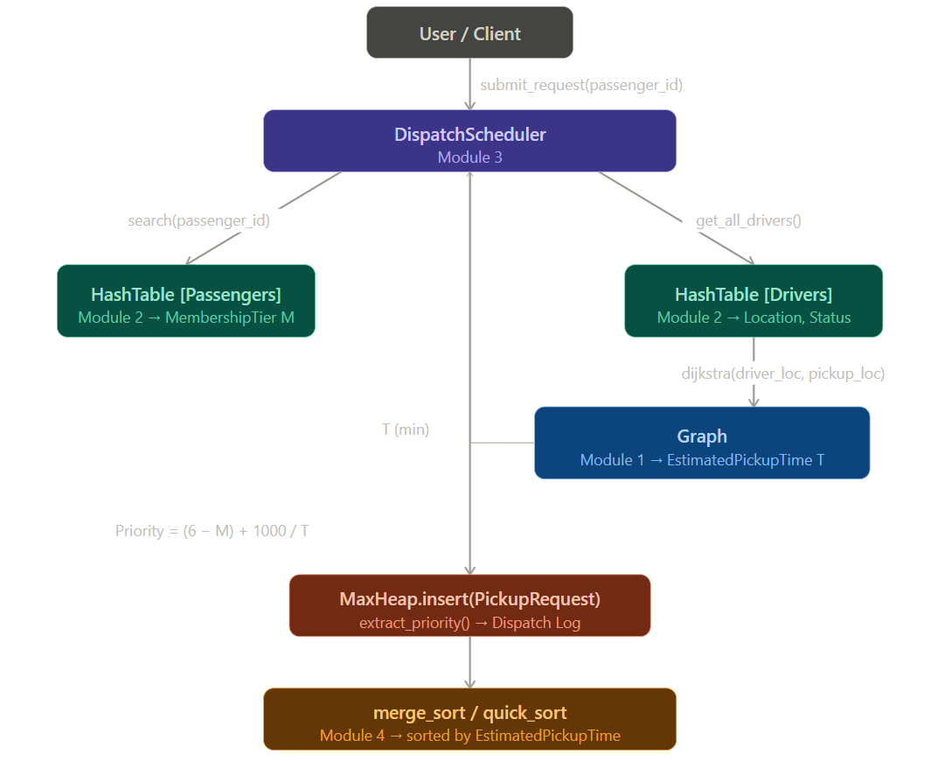
  - Class Responsibilities
Class | Responsibility
Graph | City topology; bfs(), dfs_cycle(), dijkstra(), all_pairs_times()
HashTable | O(1) insert/search/delete for PassengerRecord and DriverRecord
PassengerRecord | PassengerID, Name, PickupLocation, MembershipTier (1–5)
DriverRecord | DriverID, Name, CurrentLocation, AvailabilityStatus
PickupRequest | Self-computes Priority from M and T
MaxHeap | Array-based max-heap; insert, peek, extract_priority, update_tier
DispatchScheduler | Orchestrates Modules 1-3; submits, assigns, dispatches
merge_sort / quick_sort | Module 4 sort functions

- Algorithm Complexity
  - Module 1 - Graph
Operation | Time | Space
add_node / add_edge | O(1) amortised | O(V + E) total
BFS | O(V + E) | O(V) visited + queue
DFS cycle detection | O(V + E) | O(V) call stack + parent
Dijkstra (linear scan) | O(V²) | O(V) dist + prev
all_pairs_times() | O(V³) | O(V²) result

  - Module 2 - Hash Table
Operation | Time | Space
insert | O(1) expected; O(n) worst | O(1) per record
search | O(1) expected; O(n) worst | O(1)
delete (tombstone) | O(1) expected; O(n) worst | O(1)
resize / rehash | O(n) | O(n) new table

  - Module 3 - Max-Heap
Operation | Time | Space
insert (percolate up) | O(log n) | O(1)
peek | O(1) | O(1)
extract_priority | O(log n) | O(1)
update_tier | O(n) scan + O(log n) | O(1)
submit_request | O(D × V²) per request | O(V)

  - Module 4 - Sorting
Algorithm | Time | Space
Merge Sort | O(n log n) all cases | O(n) auxiliary
Quick Sort (med-of-3) | O(n log n) avg; O(n²) worst* | O(log n) call stack

- Sample Output
  - Module 1 - Graph
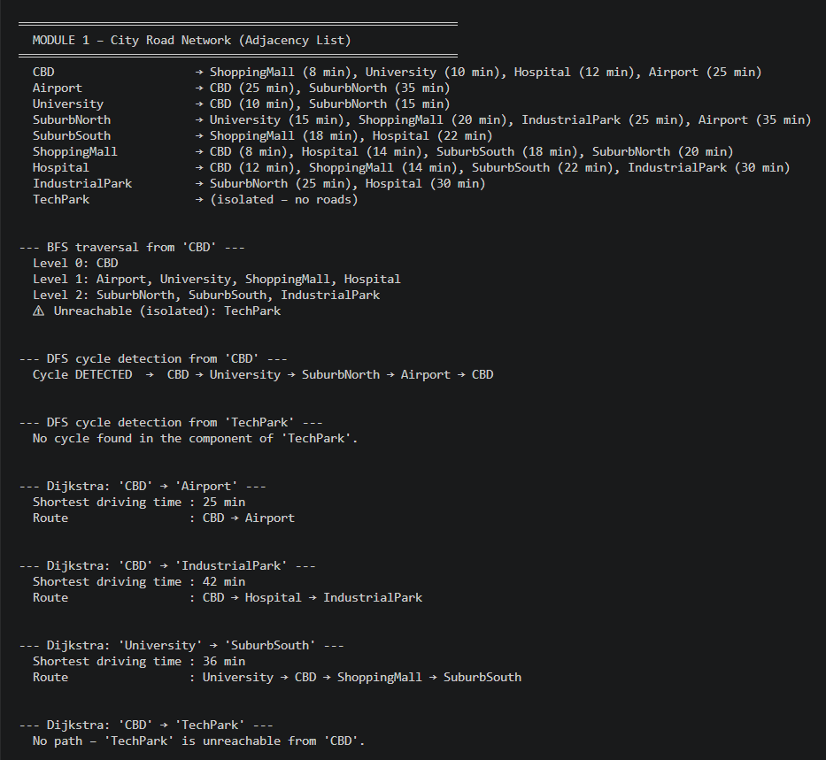
  - Module 2 - Hash Table
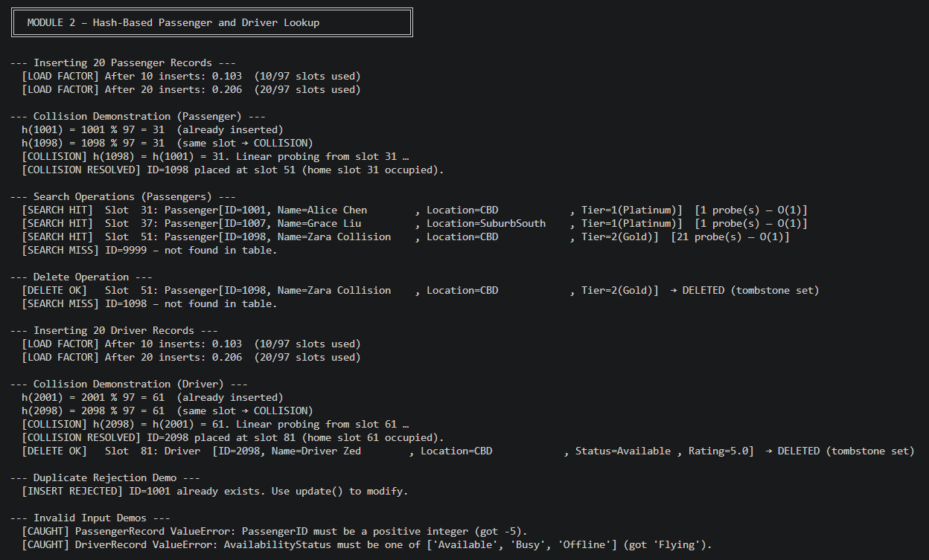
  - Module 3 - Heap
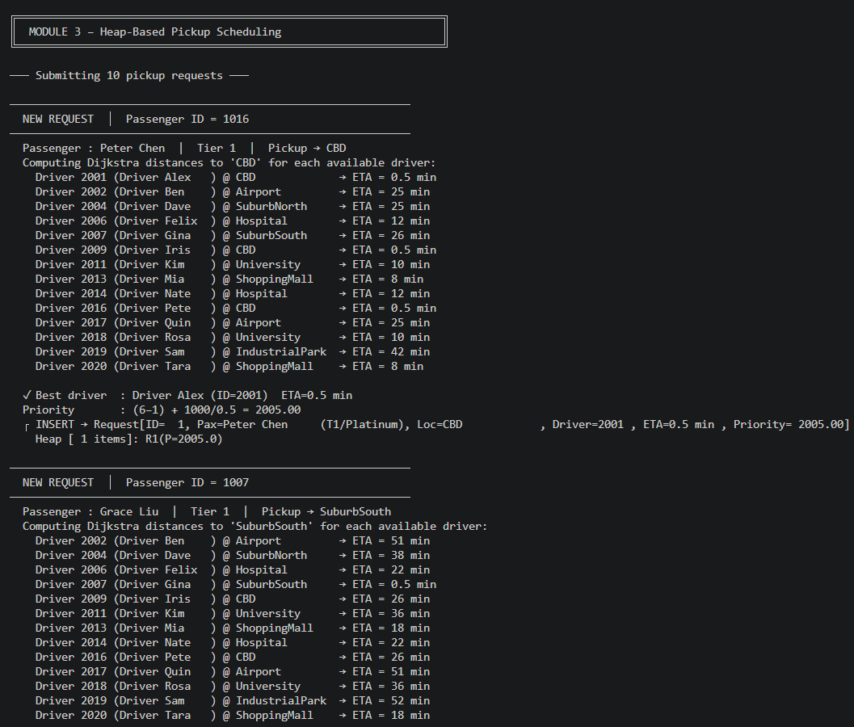
  - Module 4 - Sorting
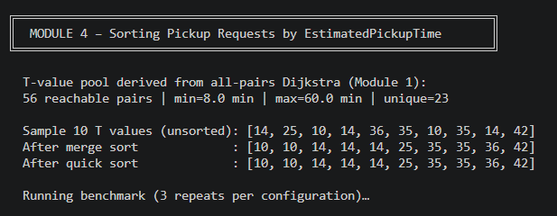
- Reflection
  - Key Learnings
  - Graph representation insight: Working with the city network made the space advantages of adjacency lists very clear. For a sparse graph, they avoid the heavy memory cost of matrices. Re implementing BFS, DFS, and Dijkstra reinforced how the visited structure prevents redundant exploration and how parent pointers make path reconstruction straightforward.
  - Hash table behavior: Open addressing proved fast and cache friendly, but the experiment with IDs 1001 - 1020 forming a long contiguous cluster highlighted how vulnerable it is to primary clustering. This reinforced why choosing a prime table size and enforcing a load factor limit are essential design decisions.
  - Heap operations: The max heap maintained O(log n) performance for both insertion and extraction regardless of request order. Seeing percolate up and percolate down in action made it clear that these two operations are the backbone of heap correctness.
  - Sorting performance: At n = 1000, Python’s function call overhead became the dominant factor. Quick Sort’s deeper recursion cost more than Merge Sort’s temporary array allocation, flipping the expected performance advantage and showing how language level, overhead can outweigh theoretical cache benefits.
  - Design Trade-offs
Decision | Choice Made | Alternative Considered
Graph storage | Adjacency list | Matrix - O(V²) space
Hash collision | Linear probing | Chaining - simpler deletion, worse cache
Heap type | Max-heap | Min-heap with negated priority
Sort for reports | Merge Sort | Quick Sort - faster at small n, unstable
Dijkstra queue | O(V²) linear scan | Binary heap - faster at large V but needs heapq

- Limitations and Assumptions
  - Known Limitations
  - Dijkstra scaling: The current Dijkstra implementation uses an O(V²) vertex scan approach. With only nine nodes, this is perfectly adequate, but a larger road network would require a binary heap priority queue to remain efficient.
  - Hash table resizing: The hash table does not automatically resize. In a production system, rehashing would be triggered whenever the load factor exceeds 0.70 to prevent clustering and degraded lookup performance.
  - Single threading: All modules run in a single thread. A real dispatch service would need concurrency control, including locks around the driver table and the heap, to avoid race conditions when multiple requests arrive simultaneously.
  - Static driver locations: Driver positions remain fixed after insertion. A live system would continuously update locations from GPS feeds, requiring dynamic graph lookups and priority recalculations.
  - Assumptions
  - Positive edge weights: All travel times are positive integers measured in minutes, ensuring Dijkstra’s algorithm remains valid.
  - Unique identifiers: Passenger ID and Driver ID values are assumed to be unique within their respective tables.
  - Same location time: A constant of 0.5 minutes is used when driver and passenger share the same node, preventing division by zero in the priority formula.
  - Benchmark reproducibility: All performance tests use a fixed random seed (42). Actual timings will vary depending on hardware and Python version.
  - Tier range: Membership tiers are restricted to the range 1–5.
- Conclusion
This project brought together four core data structure modules to form a complete ZipRide dispatch system, demonstrating how algorithmic choices shape both performance and correctness in a real-world setting. The adjacency list graph enabled efficient route computation through BFS, DFS, and Dijkstra’s algorithm, providing reliable travel time estimates across the city network. The open addressing hash table delivered constant time lookups for passengers and drivers, with linear probing handling collisions while keeping memory use compact.
The max heap scheduler proved effective for prioritizing pickup requests, combining membership tier and estimated pickup time so that high tier passengers with nearby drivers consistently rise to the top. The sorting module completed the pipeline: both Merge Sort and Quick Sort were implemented from first principles and benchmarked under multiple dataset conditions, with Merge Sort emerging as the more reliable choice for stable end of day reporting.
All modules were integrated into a single workflow where each component feeds cleanly into the next, and the system handled edge cases such as collisions, tier updates, missing records, and unavailable drivers without failure. No built-in data structure libraries were used for the core logic, reinforcing the educational goal of understanding how these structures behave internally.
Overall, the project shows how thoughtful data structure selection directly influences the responsiveness and robustness of a dispatch system an insight that carries over to real ride hailing platforms where efficiency and fairness matter at scale.

- References
[1] T. H. Cormen, C. E. Leiserson, R. L. Rivest, and C. Stein, Introduction to Algorithms, 4th ed. Cambridge, MA: MIT Press, 2022. [Online]. Available: https://mitpress.mit.edu/9780262046305/introduction-to-algorithms/
[2] E. W. Dijkstra, "A note on two problems in connexion with graphs," Numerische Mathematik, vol. 1, no. 1, pp. 269–271, 1959. [Online]. Available: https://link.springer.com/article/10.1007/BF01386390
[3] M. T. Goodrich, R. Tamassia, and M. H. Goldwasser, Data Structures and Algorithms in Python. Hoboken, NJ: Wiley, 2013. [Online]. Available: https://www.wiley.com/en-us/Data+Structures+and+Algorithms+in+Python-p-9781118290279
[4] C. A. R. Hoare, "Quicksort," The Computer Journal, vol. 5, no. 1, pp. 10–16, 1962. [Online]. Available: https://academic.oup.com/comjnl/article/5/1/10/395338
[5] D. E. Knuth, The Art of Computer Programming, Volume 3: Sorting and Searching, 2nd ed. Reading, MA: Addison-Wesley, 1998. [Online]. Available: https://www.informit.com/store/art-of-computer-programming-volume-3-sorting-9780201896855
[6] Python Software Foundation, "Python 3 Documentation," 2025. [Online]. Available: https://docs.python.org/3/
[7] R. Sedgewick and K. Wayne, Algorithms, 4th ed. Upper Saddle River, NJ: Addison-Wesley Professional, 2011. [Online]. Available: https://algs4.cs.princeton.edu/home/
[8] J. W. J. Williams, "Algorithm 232: Heapsort," Communications of the ACM, vol. 7, no. 6, pp. 347–348, 1964. [Online]. Available: https://dl.acm.org/doi/10.1145/512274.512284

